TEAMWORK 5
Simulation Study of the Strong Law of Large Numbers (SLLN)
and the Central Limit Theorem (CLT)
IE 221 Probability — Simulation Project
Team Members
Name | Student ID | Role
Ecem Nur Yüksel | 2411013097 | Simulation Lead & Code Architect
Fatmanur Doğan | 2311021001 | Theoretical Background & Standard-Case Results
Ayşe Efsa Çelik | 221021001 | Results Analyst (Standard Cases)
İbrahim Genç | 2211021036 | Anomaly Analysis & Report Editor

Abstract
This report presents a Monte Carlo simulation study of the Strong Law of Large Numbers (SLLN) and the Central Limit Theorem (CLT) across five distributions: Uniform(0,1), Exponential(1), Pareto(α=3), Pareto(α=1.5), and Cauchy. We compare standard cases—where both the first and second moments are finite—with heavy‑tailed or undefined‑moment cases that violate theorem assumptions. The results show stable convergence and near‑normal standardized means for Uniform, Exponential, and Pareto(α=3), while Pareto(α=1.5) and Cauchy exhibit anomalous behavior due to infinite variance and undefined moments, respectively.

Purpose
The objective of TEAMWORK 5 is to empirically verify SLLN and CLT under different moment conditions and to document anomalies when classical assumptions fail. Specifically, we:
- simulate SLLN convergence of the cumulative sample mean for each distribution;
- test CLT using standardized sample means and compare to the standard normal distribution;
- connect observed failures to theoretical conditions such as infinite variance or undefined moments.

1. Introduction
Convergence theorems justify the use of sample averages and normal approximations in statistics. In practice, however, data may arise from heavy‑tailed distributions where moments are infinite or undefined. This project visualizes convergence behavior through simulation and links outcomes to the mathematical assumptions behind SLLN and CLT.

2. Theoretical Background
Let {Xᵢ} be i.i.d. random variables with sample mean X̄ₙ. The SLLN and CLT have different assumptions:
• SLLN (Kolmogorov): if E[|X|] < ∞, then X̄ₙ → E[X] almost surely.
• Classical CLT: if Var(X)=σ² < ∞, then √n (X̄ₙ − μ) / σ ⇒ N(0,1).
When these moment conditions fail, convergence may become slow, unstable, or completely absent.

2.1 Moments of Distributions
Table 1 summarizes the theoretical moments used in the report.
Distribution | E[X] | Var(X)
Uniform(0,1) | 1/2 | 1/12
Exponential(1) | 1 | 1
Pareto (α=3) | 1/(α−1)=0.5 | α/((α−1)²(α−2)) = 0.75
Pareto (α=1.5) | 1/(α−1)=2 | Infinite (α ≤ 2)
Cauchy | Undefined | Undefined

3. Methodology
SLLN was simulated by generating n = 10,000 i.i.d. samples per distribution and plotting the cumulative mean Sₙ = (1/n)∑ᵢ Xᵢ versus n. For CLT, we generated m = 10,000 replications of sample means with sample size n = 50. For distributions with finite variance, we used theoretical μ and σ to compute Z = (X̄−μ)/(σ/√n). For anomaly cases (Pareto α=1.5 and Cauchy), theoretical σ is not finite/defined, so we standardized using sample statistics to illustrate the breakdown of classical CLT assumptions.

4. Results

4.1 SLLN Convergence
Figures 1–5 display the convergence behavior of the cumulative sample mean. Distributions with a finite mean show stabilization toward the theoretical mean, while heavy‑tailed or undefined‑moment distributions exhibit slow or unstable trajectories.
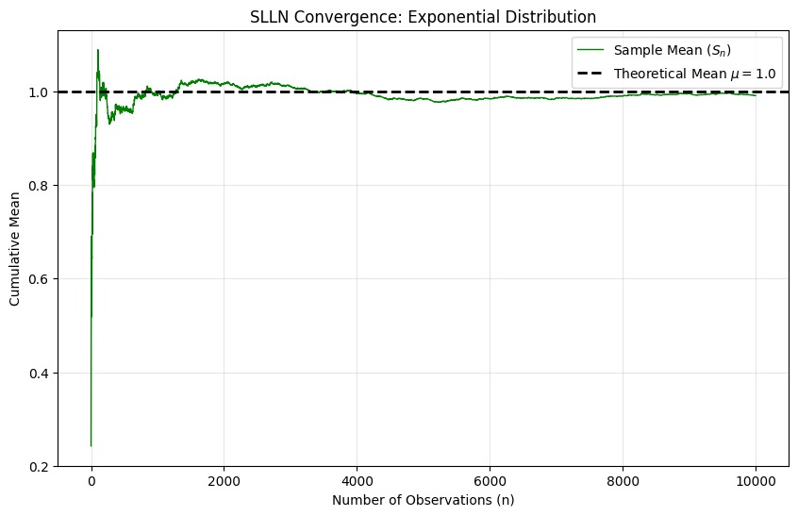
Figure 1. SLLN Convergence: Exponential Distribution
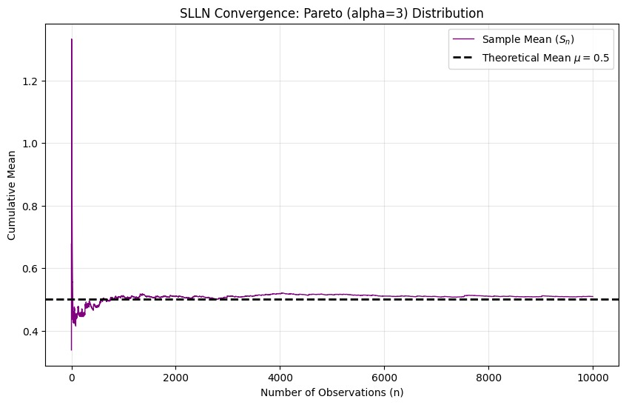
Figure 2. SLLN Convergence: Pareto (α = 3) Distribution
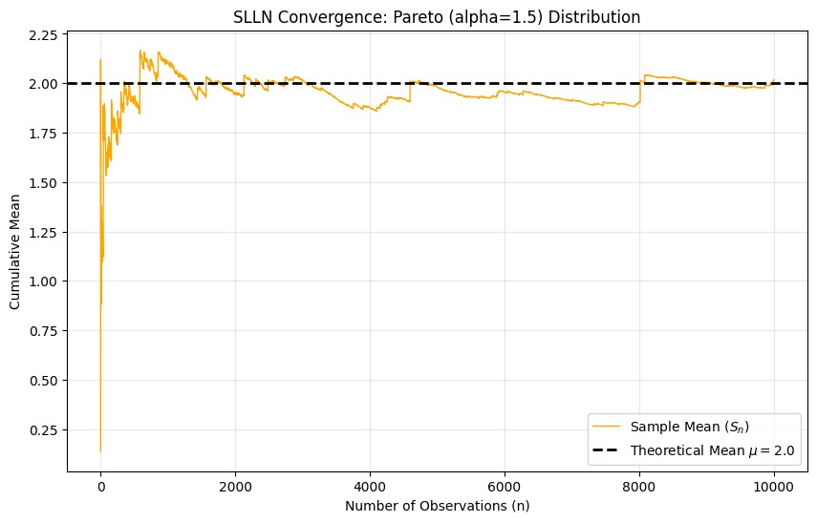
Figure 3. SLLN Convergence: Pareto (α = 1.5) Distribution
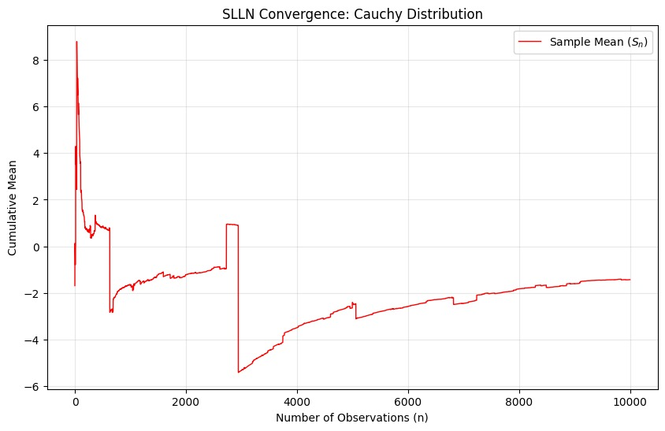
Figure 4. SLLN Convergence: Cauchy Distribution
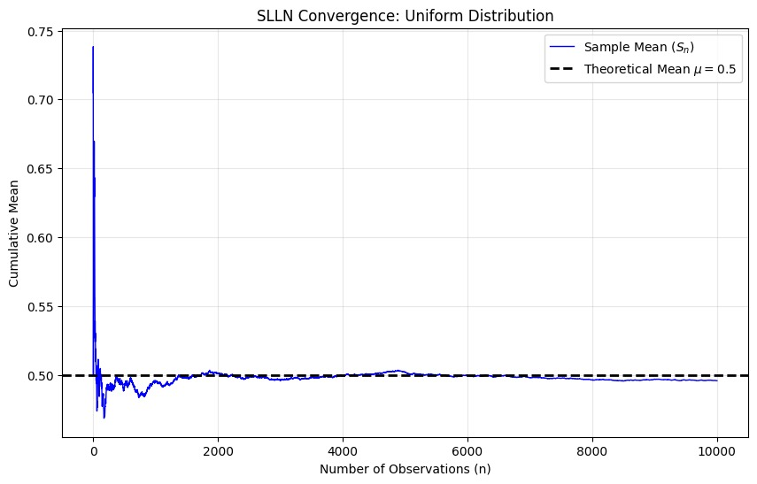
Figure 5. SLLN Convergence: Uniform Distribution

4.2 CLT Histograms (Standardized Means)
Figures 6–10 compare the empirical histogram of standardized sample means to the standard normal density. Standard cases follow N(0,1) closely, while anomaly cases deviate significantly.
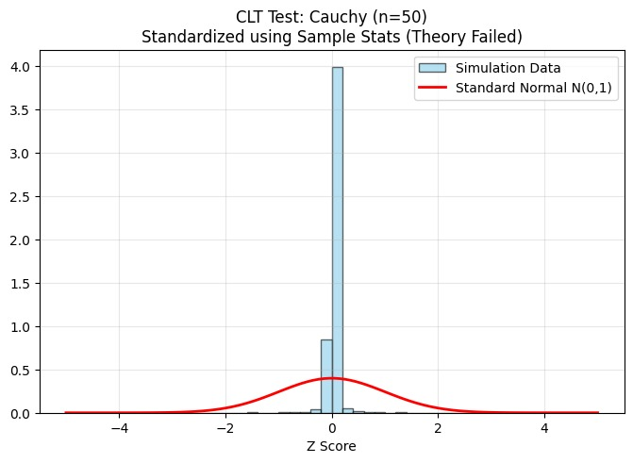
Figure 6. CLT Test: Cauchy (n = 50) — Standardized using Sample Stats (Theory Failed)
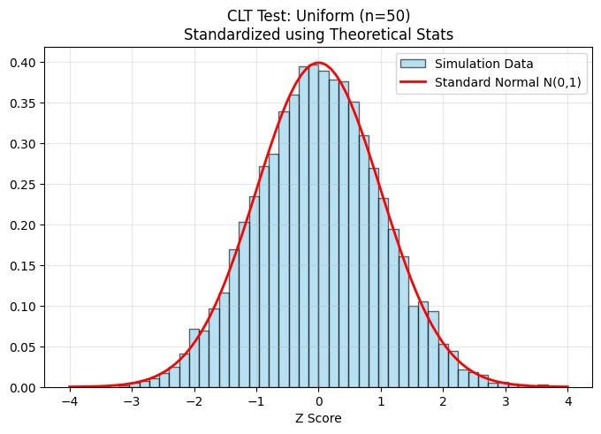
Figure 7. CLT Test: Uniform (n = 50) — Standardized using Theoretical Stats
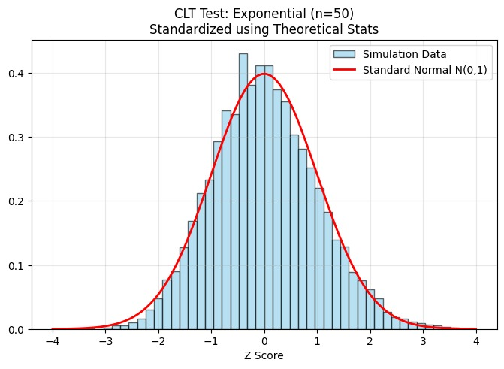
Figure 8. CLT Test: Exponential (n = 50) — Standardized using Theoretical Stats
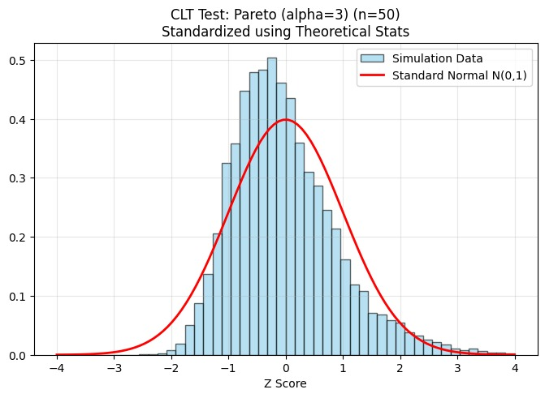
Figure 9. CLT Test: Pareto (α = 3, n = 50) — Standardized using Theoretical Stats
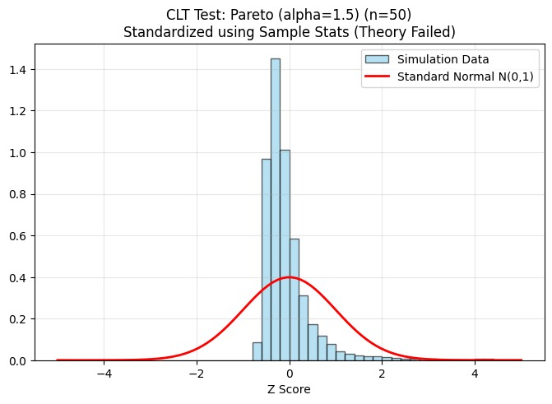
Figure 10. CLT Test: Pareto (α = 1.5, n = 50) — Standardized using Sample Stats (Theory Failed)

5. Discovery of Anomalies and Discussion
Our simulation study tests the Strong Law of Large Numbers (SLLN) and the Central Limit Theorem (CLT) on several distributions. The key point is that these theorems do not have the same requirements.
SLLN (Kolmogorov, i.i.d. case) typically requires a finite first absolute moment, E[|X|] < ∞. If this holds, then the sample mean converges almost surely to the true mean: X̄ₙ → E[X].
CLT (classical version) requires a finite variance, Var(X) < ∞, so that √n (X̄ₙ − μ) / σ ⇒ N(0,1).
Therefore, when mean and/or variance is infinite or undefined, we should expect the standard convergence patterns to break.
Anomaly 1 — Pareto Distribution with α = 1.5:
For Pareto distributions with α = 1.5, the mean exists but the variance is infinite. As a result, the Strong Law of Large Numbers may hold in theory, but convergence is extremely slow and unstable in finite samples. The Central Limit Theorem fails because its finite‑variance assumption is violated. In simulations, the cumulative mean often appears to stabilize temporarily, then suddenly jumps due to rare extreme values. Histograms of standardized means do not approach the normal distribution; instead, heavy tails dominate the behavior.
Anomaly 2 — Cauchy Distribution:
For the Cauchy distribution, neither the mean nor the variance exists. Consequently, neither SLLN nor CLT applies. The cumulative mean does not converge; it continues to fluctuate regardless of sample size. This is consistent with the stability property of the Cauchy distribution: the average of i.i.d. Cauchy variables has the same distribution as the original variable.
Comparative Interpretation:
Uniform, Exponential, and Pareto (α = 3) have finite mean and variance → SLLN and CLT both hold.
Pareto (α = 1.5) has finite mean but infinite variance → SLLN may hold, CLT fails.
Cauchy has undefined mean and variance → neither SLLN nor CLT holds.
These results confirm that convergence theorems critically depend on moment conditions.

Appendix A — Updated SLLN Code
import numpy as np
import matplotlib.pyplot as plt
import os

def run_slln_multidistribution(n=10000):
"""
Simulates SLLN for 5 different distributions:
1. Uniform (Control)
2. Exponential (Standard)
3. Pareto (alpha=3, Finite Variance)
4. Pareto (alpha=1.5, Infinite Variance -> Anomaly)
5. Cauchy (Undefined Mean -> Anomaly)
"""

# Klasör kontrolü
save_path = 'results/figures'
if not os.path.exists(save_path):
os.makedirs(save_path)

# Dağılımların ve Teorik Ortalamalarının Tanımlanması
# Pareto notu: np.random.pareto(a) Lomax dağılımıdır (Type II).
# Mean = 1 / (a - 1)
distributions = {
"Uniform": {
"func": lambda size: np.random.uniform(0, 1, size),
"mu": 0.5,
"color": "blue"
},
"Exponential": {
"func": lambda size: np.random.exponential(1, size),
"mu": 1.0,
"color": "green"
},
"Pareto (alpha=3)": {
"func": lambda size: np.random.pareto(3.0, size),
"mu": 1.0 / (3.0 - 1.0), # Mean = 0.5
"color": "purple"
},
"Pareto (alpha=1.5)": {
"func": lambda size: np.random.pareto(1.5, size),
"mu": 1.0 / (1.5 - 1.0), # Mean = 2.0 (Ama varyans sonsuz)
"color": "orange"
},
"Cauchy": {
"func": lambda size: np.random.standard_cauchy(size),
"mu": None, # Tanımsız
"color": "red"
}
}

print("SLLN Simülasyonu Başlıyor (5 Dağılım)...")

for name, params in distributions.items():
# 1. Veri Üret
X = params["func"](n)

# 2. Kümülatif Ortalama Hesapla
S_n = np.cumsum(X) / np.arange(1, n + 1)

# 3. Çizim
plt.figure(figsize=(10, 6))
plt.plot(S_n, label=f'Sample Mean ($S_n$)', color=params["color"], linewidth=1)

# Teorik Ortalama Varsa Çiz (Cauchy'de yok)
if params["mu"] is not None:
plt.axhline(y=params["mu"], color='black', linestyle='--', linewidth=2, label=f'Theoretical Mean $\mu={params["mu"]}$')

plt.title(f'SLLN Convergence: {name} Distribution')
plt.xlabel('Number of Observations (n)')
plt.ylabel('Cumulative Mean')
plt.legend()
plt.grid(True, alpha=0.3)

# Kaydet
filename = f"slln_{name.replace(' ', '_').replace('(', '').replace(')', '').replace('=', '')}.png"
full_path = os.path.join(save_path, filename)
plt.savefig(full_path)
print(f"Grafik kaydedildi: {filename}")
plt.show() # Colab'de görmek için

# Çalıştır
if __name__ == "__main__":
run_slln_multidistribution()

Appendix B — Updated CLT Code
import numpy as np
import matplotlib.pyplot as plt
from scipy.stats import norm
import os

def run_clt_multidistribution(n=50, m=10000):
"""
Simulates CLT for 5 distributions.
n: Sample size (örneklem büyüklüğü)
m: Number of replications (tekrar sayısı)
"""

save_path = 'results/figures'
if not os.path.exists(save_path):
os.makedirs(save_path)

# Dağılım Parametreleri (Teorik Mean ve Std Dev)
# Pareto Varyans: a / ((a-1)^2 * (a-2)) (Sadece a > 2 için geçerli!)
distributions = [
("Uniform", lambda s: np.random.uniform(0, 1, s), 0.5, np.sqrt(1/12)),
("Exponential", lambda s: np.random.exponential(1, s), 1.0, 1.0),
("Pareto (alpha=3)", lambda s: np.random.pareto(3, s), 0.5, np.sqrt(3/((2**2)*1))), # sigma = sqrt(0.75) = 0.866

# ANOMALİLER (Varyans sonsuz veya tanımsız)
# Burada "sample std" kullanarak normalize etmeyi deneyeceğiz ki hatayı görelim.
("Pareto (alpha=1.5)", lambda s: np.random.pareto(1.5, s), 2.0, None),
("Cauchy", lambda s: np.random.standard_cauchy(s), None, None)
]

print(f"CLT Simülasyonu Başlıyor (n={n}, m={m})...")

for name, func, mu_theo, sigma_theo in distributions:

# 1. Veri Üretimi (m x n matrisi)
samples = func((m, n))

# 2. Toplamları ve Ortalamaları Hesapla
means = np.mean(samples, axis=1)

# 3. Standardizasyon (Z Hesaplama)
if sigma_theo is not None:
Z = (means - mu_theo) / (sigma_theo / np.sqrt(n))
label_text = "Standardized using Theoretical Stats"
else:
Z = (means - np.mean(means)) / np.std(means)
label_text = "Standardized using Sample Stats (Theory Failed)"

# 4. Çizim (Histogram vs Normal PDF)
plt.figure(figsize=(8, 5))

if "Cauchy" in name or "1.5" in name:
range_limit = (-5, 5)
else:
range_limit = (-4, 4)

plt.hist(Z, bins=50, density=True, range=range_limit, alpha=0.6,
color='skyblue', edgecolor='black', label='Simulation Data')

x = np.linspace(range_limit[0], range_limit[1], 100)
plt.plot(x, norm.pdf(x), 'r-', lw=2, label='Standard Normal N(0,1)')

plt.title(f'CLT Test: {name} (n={n})\n{label_text}')
plt.xlabel('Z Score')
plt.legend()
plt.grid(True, alpha=0.3)

filename = f"clt_{name.replace(' ', '_').replace('(', '').replace(')', '').replace('=', '')}.png"
full_path = os.path.join(save_path, filename)
plt.savefig(full_path)
print(f"Grafik kaydedildi: {filename}")
plt.show()

if __name__ == "__main__":
run_clt_multidistribution()

6. Conclusion
The simulations confirm that the validity of convergence theorems depends critically on moment conditions. Uniform, Exponential, and Pareto (α=3) satisfy finite mean and variance, so SLLN and CLT behave as expected. Pareto (α=1.5) violates the finite‑variance assumption, producing unstable averages and a clear failure of the classical CLT. The Cauchy distribution, with undefined mean and variance, breaks both SLLN and CLT, and sample means remain highly volatile regardless of sample size. These findings emphasize that normal approximations must be justified by verifying distributional assumptions.

